**Shaft Component Generator (Version: 2023.1 (Build 271208000, 208))**

1/31/2023

### Project Info (iProperties)

Summary

|  |  |
| --- | --- |
| Title |  |
| Subject | -  engma |
| Author |
| Manager |
| Company |  |
| Category |  |
| Keywords |  |
| Comments |  |

Project

|  |  |
| --- | --- |
| Part Number | diff shaft |
| Stock Number |  |
| Description |  |
| Revision Number |  |
| Project |  |
| Designer | engma |
| Engineer |  |
| Authority |  |
| Cost Center |  |
| Cost | $0.00 |
| Date Created | 1/30/2023 |
| Vendor |  |
| Catalog web link |  |

Status

|  |  |
| --- | --- |
| User Status |  |
| Design Status | 1 |
| Last Saved By |  |
| Checked by |  |
| Engr Approved by |  |
| Date Eng Approved |  |
| Part Type name | Assembly |
| Mfg Approved by |  |
| Date Mfg Approved |  |
| Standard |  |
| Manufacturer |  |
| Standards Organization |  |

### Calculation

Materia

|  |  |  |
| --- | --- | --- |
| Material Steel, nickel | | |
| Modulus of Elasticity E | | 205000 psi |
| Modulus of Rigidity | G  _e | 80000 psi |
| Density | 8280 lbmass/ft"3 |

Calculation Properties

|  |  |  |  |
| --- | --- | --- | --- |
| Include |  | I | |
| Yes | Density | p I8280 lbmass/ft"3 | |
| - Yes | Shear Displacement Ratio |  | 1.188ul |
| Number of Divisions | I 1000.000 ul | |
|  | Mode of reduced stress | I HMH | |

Loads



Direction

55.18 deg

Deflection Angle

Location

Index

Supports

Index Type ,

|  |  |  |  |  |  |  |  |  |  |  |  |
| --- | --- | --- | --- | --- | --- | --- | --- | --- | --- | --- | --- |
| LocationLI |  |  | Reaction Force |  | _ | Yielding Type | y | Deflection  _r] Size | I | Direction | Deflection Angle |
| **Y** | **El** | Size I Direction | **Axial**  Force | |



I

149.25

Fixed mm

-824.695

lbforce

180.00

deg

I

User

21.81 deg

I

Free 1244.5 mm 1397.473 lbforce

12.91 deg

180.00

deg

4.074

microin

microin

User1-4.074

2

180.00

deg

2.617

microin

-2.617

microin

824.695

lbforce

397.473

lbforce

Results

Length L

|  |
| --- |
| 10.157 in  22.395 lbmass |
| 26872.123 psi |
| 1269.217 psi |
| 0.000 psi |
| 0.000 psi |
| 26907.546 psi |
| 4880233.108 microin |
| 0.00 deg |

Mass Mass

## Os

|  |
| --- |
| Maximal Bending Stress |
| Maximal Shear Stress |
| Maximal Torsional Stress |
| Maximal Tension Stress |
| Maximal Reduced Stress |
| Maximal Deflection |
| Angle of Twist |

T5

-- T

*aT*

Ored

fmax

#### _cp_

Preview

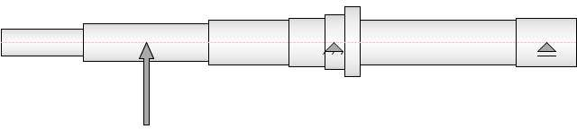

Shear Force

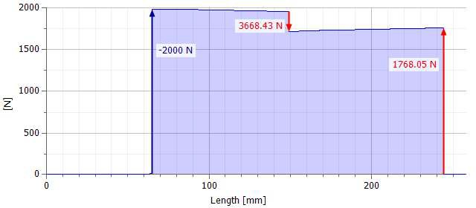

Shear Force, YZ Plane

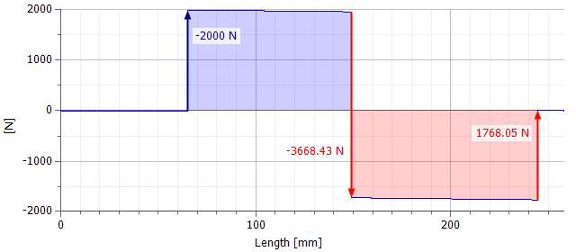

Shear Force, XZ Plane



0.5 -- - - - - - - - --+--

0+

+

+

-0.5 --

-f--

0 100

Length [mm]

200

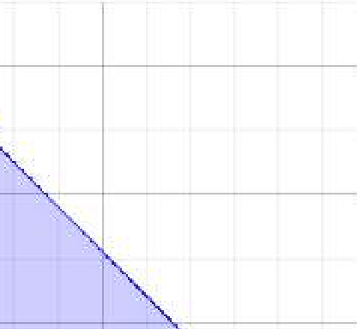Bending Moment

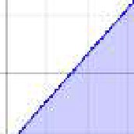

150

165.73

100

50

_4-

100

Length [mm]

200

Bending Moment, YZ Plane

150-+

+-

,,

100

50

I

0

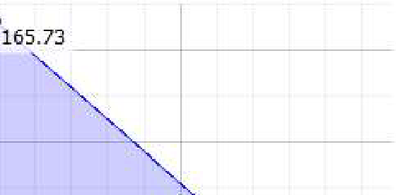

E

*b*

-0.36B833

0 100

Length [mm]

200

Bending Moment, XZ Plane



1-

0.5 -- -------------+-------- --- -+--------

0-+

+-

+

-0.5 -- - - - - - - -

0 100

Length [mm]

200

Deflection Angle

60

56.2708

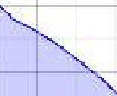50

40

30

01

*<])*

20

10

--+----·--

0.0509858,

0+--r--c-- ----r--------,--r----,--------,-,-----i----,--_c-----r------r----r----r--------,--'!Cl'---,----,---,-----r ,--_ J

0 100 200

Length [mm]

Deflection Angle, YZ Plane

10

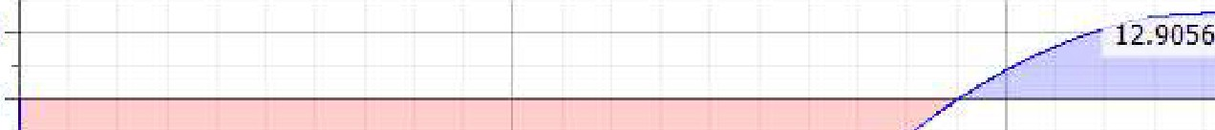

-i------------- 56.270I

I/

8

0

-10

-20

#### 01

*<])* -30

-40

-50

-60

0

100

Length [mm]

200

Deflection Angle, XZ Plane

1

0.5 -- - - - - - - -

0+ + 1

01

*<])*

-0.5 --

-f--

-1+-----r--------,--r----,----,---c-- --r--------,-+-----,----,---c-- --r--------,-r----,----,-------l--r----r- -,-----r---

0 100

Length [mm]

200

Deflection

123958



100000- - +- +

'?

##### 2

..s

50000

100

Length [mm]

200

Deflection, YZ Plane

123958

100000

E

2u 50000

# E

0 +-------------;------""---=;:;-----S305.84 _;_;_;.=--=- =

100

Length [mm]

200

Deflection, XZ Plane



1-

0.5 -- ------------+-------- --- -+--------

Eo-+

2

..s

-0.5 --

+

+

- - - - - - -

0 100

Length [mm]

200

Bending Stress

200

185.277

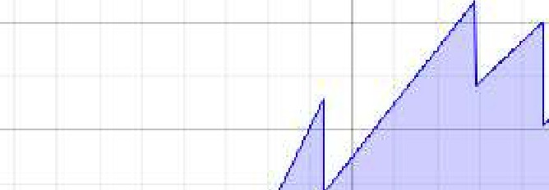150

'iii' 100

0..

# 6

50

0

0 100

Length [mm]

200

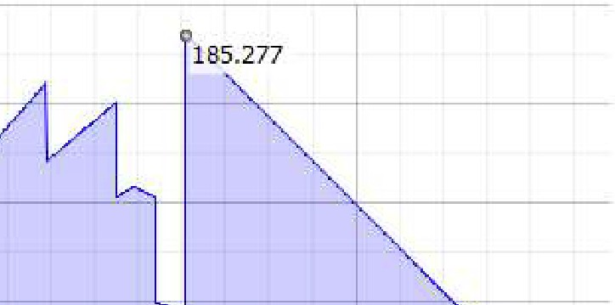Bending Stress, YZ Plane

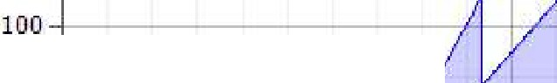

200

150

50-+-----------/·

0-;

o

-0.764686

t

t

-

#### 'iii'

0..

## 6

100

Length [mm]

200

Bending Stress, XZ Plane

Ill



0.5 -- - - - - - - -

0+

+

1

-0.5 --

-f--

6"-

0 100

Length [mm]

200

Shear Stress

g

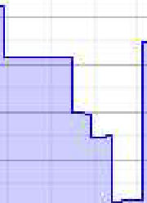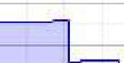

B

B.75094 I

7

6

##### 5-t +

4+-----------I -+

*L*

3-+

2+--------------1

1

a- - - - - -

100

Length [mm]

Shear Stress, YZ Plane

I

L

i

r-s.5ss37

B.75094 I

5

-+-

-.--'-- -

.200

Ill

l

#### o

-5

0

100

Length [mm]

200

Shear Stress, XZ Plane



1

0.5 -- -----------+-------- --- -+--------

□-+

+

,

-0.5 -- - -

0 100

Length [mm]

200

Torsional Stress

Ill



0.5 -- - - - - - - -

0+

+

1

-0.5 --

-f--

6"-

0 100

Length [mm]

200

Tension Stress



1

0.5 -- -----------+-------- --- -+--------

0-+

+

,

-0.5 -- - -

0 100

Length [mm]

200

Reduced Stress

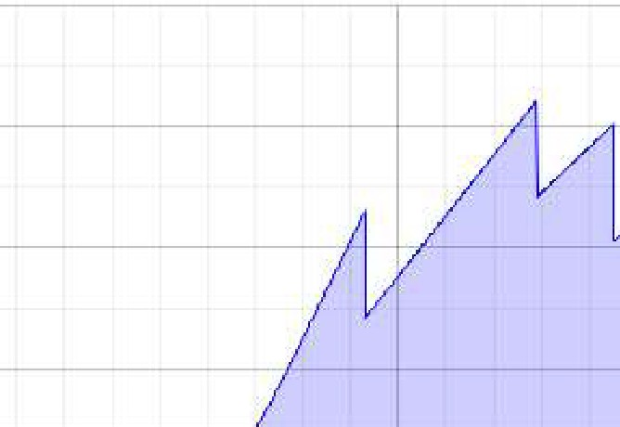200

185.521

150

'iii' 100

6"-

50

0

0 100

Length [mm]

200

Ideal Diameter

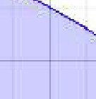E E

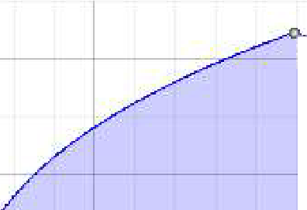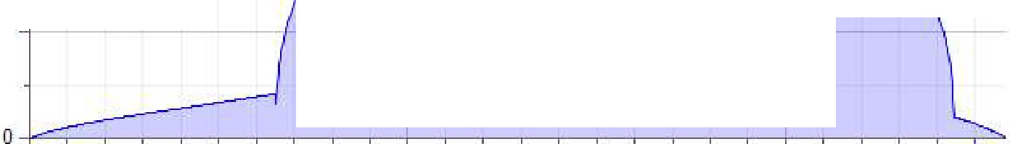

30

**32.3204**

20

10

+

0 100 200

Length [mm]

Summary of Messages

I1:08:16 PM Calculation: Calculated.I